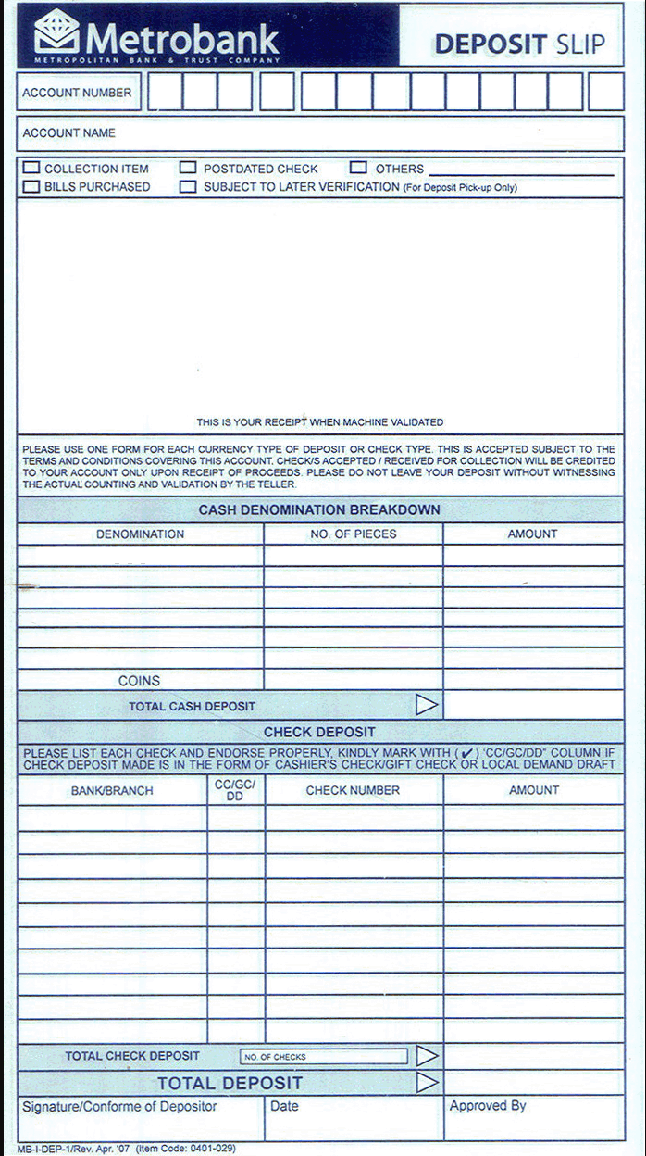

Downloaded from <http://www.affordablecebu.com>